
A12
Sreenidhi Institute of Science and Technology
(An Autonomous Institution)
Code No: 3F517
B. TECH. III-Year I-Semester Examinations, December 2015 (Supplementary)
THEORY OF COMPUTATION (CSE & IT)

Time: 3 Hours Max. Marks: 70

Note: No additional answer sheets will be provided.

Part - A
Max.Marks:20

Answer all QUESTIONS. EACH QUESTION CARRIES 2 MARKS.
- Why are switching circuits called as finite state systems?
- Write the properties of Transition Function.
- List the operations on Languages.
- What is the language generated by CFG?
- Define Instantaneous description of Turing Machine.
- Explain concepts used in UTMs?
- What are the components of Finite automaton model?
- Is it true that the language accepted by a PDA by empty stack and final states are different languages.
- What is a multi-tape Turing machine?
- Define P and NP Problems?
Part – B
Max.Marks:50

ANSWER ANY FIVE QUESTIONS. EACH QUESTION CARRIES 10 MARKS.
- a) Differentiate between deterministic finite automaton and non-deterministic finite automaton.
[6M]
b) Explain the transition diagram of a finite automaton. [4M]
2. a) What is NFA? Explain how an equivalent DFA is obtained from NFA. [4M]
b) Construct DFA equivalent to the following finite state machine. [6M]

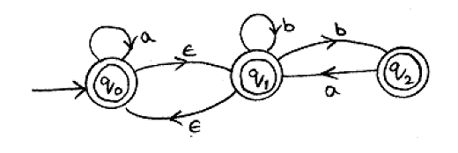

- a) Write the recursive definition for regular expression and prove that every regular
expression can be represented by an NFA with transitions. [6M]
b) Show that the set is not regular. [4M]

4. a) Convert the following to Greiback normal form for the grammar where P consists of the following: [5M]
b) What is meant by ambiguous grammar? Test whether the following grammar is ambiguous or not.
[5M]

5. a) Design Turing Machine to recognize the following. [6M]
    - To find out proper subtraction of two integers.
    - To recognize
b) Explain the procedure involved in the design of Turing Machine. [4M]

6. a) Construct LR(0) items for the grammar given below, find its equivalent DFA. Check the parsing by taking a suitable derived string. [6M]
b) What is decidability? Explain any two undecidable problems. [4M]

7. a) Construct the Moore machine for given Melay machine [6M]
 |  | 1 |  | 0
 |  | 1 |  | 1
 |  | 1 |  | 1
 |  | 0 |  | 1

b) Differentiate between right linear and left linear grammars. [4M]

8. a) Design Turing Machine to compute the following functions. [6M]
b) Write short notes on any two of the following. [4M]
- NP-hard problems
- PCP
- UTM

-- 00 -- 00 –

